**Study trip in Austria**

**December 2019**

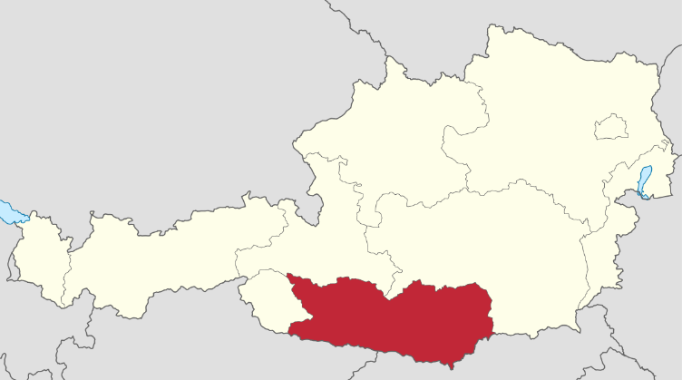Großglockner/Mölltal - Oberdrautal local action group (LAG) of the Austrian region organizes a wonderful study trip to Carinthia (Kärnten) of Austria. Carinthia is famous for its beautiful nature. This includes mountains, lakes, resorts, and many attractions. This part of Austria is full of historical, architectural and natural objects that are included in the list of many tourist attractions.

**Monday, 02.12.2019**

Arrival airport Klagenfurt, visit Klagenfurt and Wörther lake and check in hotel Oberst Bergmeisteramt Obervellach or Kärntner Hof Heiligenblut

**Thusday, 03.12.2019**

08:00 Breakfast

09:00 Presentation of the Austrian region of Großglockner/Mölltal - Oberdrautal and study trip program and information about Multifund ans CLLD Michael Hohenwarter

Information from the carinthian goverment about the new period 2021-2027 with Multifund

11:30 Visit Obervellach (Rural Development Programme (RDP) Infrastructure improvement and Public activities)

12:00 Obervellach Small business Park (LEADER Business development project)

12:30 Visit Groppensteinschlucht (LEADER Tourism development project)

13:00 Lunch

14:30 Presentation of Obervellach's cultural historical route

16:00

18:00 Dinner

Discussion about visited objects. Presentation of the next day's program

**Wednesday, 04.12.2019**

08:00 Breakfast

09:00 Trip to Mallnitz

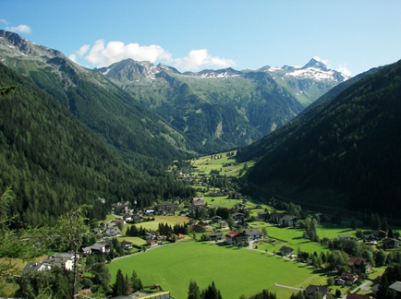09:30 Presentation of Mallnitz Railway Station (LEADER and RDP infrastructure improvement project)

10:00 Visit of Mallnitz (LEADER infrastructure improvement and public activity project)

10:30 Visit of the Cultural center Pro Musica Mallnitz (LEADER cultural activity project)

13:00 Lunch

14:30 Visit of Mallnitz pool (LEADER tourism development project) and wood construction Stall

18:00 Dinner.

Discussion about visited objects. Presentation of the next day's program

**Thusday, 05.12.2019**

07:30 Breakfast

08:30 Trip to Flattach

09:00 Visit of Sporthotel Mölltal (RDP tourism development project)

09:30 Visit of Youth hostel Mölltaler Gletscher (RDP tourism development project)

10:00 Visit of the Mölltaler Gletscher Ski Resort. „Experience 3000“. (RDP and LEADER tourism development projects)

12:00 Lunch

13:30 Presentation of the region's Großglockner/Mölltal - Oberdrautal tourism situation

14:30 Arrival at Gletscher Express into the valley

16:00 Walking in Heiligenblut, visit project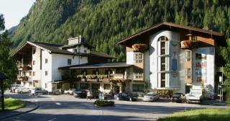

<https://www.hotel-kaerntnerhof.com/>

17:30 Visit of the Grosskircheim Kohlbarren (LEADER cultural project)

20:00 Dinner.

Short presentation about hotel activities

Discussion about visited objects

back to Oberstbergmeisteramt or Kärntner Hof

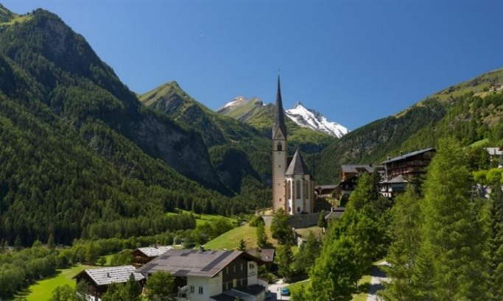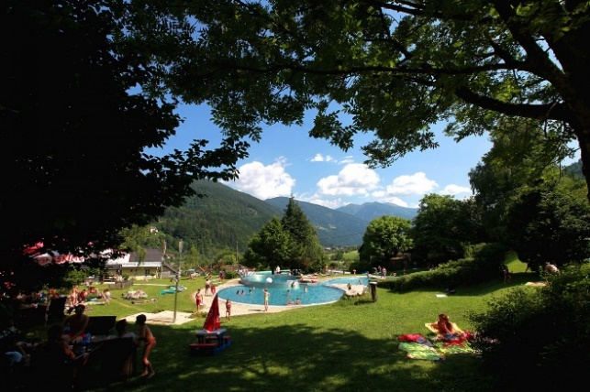

**Friday, 06.12.2019**

05:00 Breakfast Breakfast, depence from the departure in Klagenfurt

06:00 Departure to the airport