Study visit in Austria
December 2019

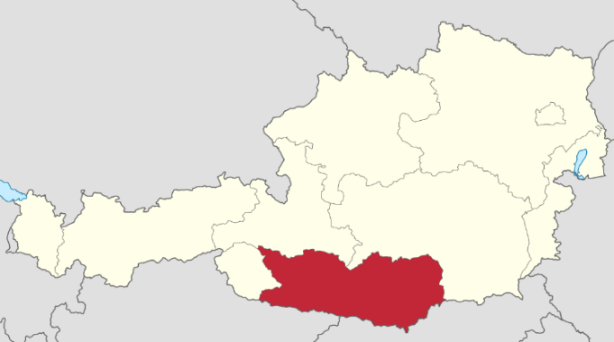
LAG Großglockner/Mölltal - Oberdrautal local action group of the Austrian region organizes a wonderful study trip to Carinthia (Kärnten) of Austria. Carinthia is famous for its beautiful nature. This includes mountains, lakes, resorts, and many attractions. This part of Austria is full of historical, architectural and natural objects that are included in the list of many tourist attractions.

Monday, 02.12.2019
06:40 — 8:10 Flight Tallinn (TLL) - Frankfurt am Main (FRA), 2:30 hours, Lufthansa
09:15 — 10:30 Flight Frankfurt am Main (FRA) - Ljubljana (LJU), 1:15 hours, Lufthansa
12:30 Arrival Klagenfurt
12:45 Lunch
13:30 Tour in Klagenfurt and Wörtherlake
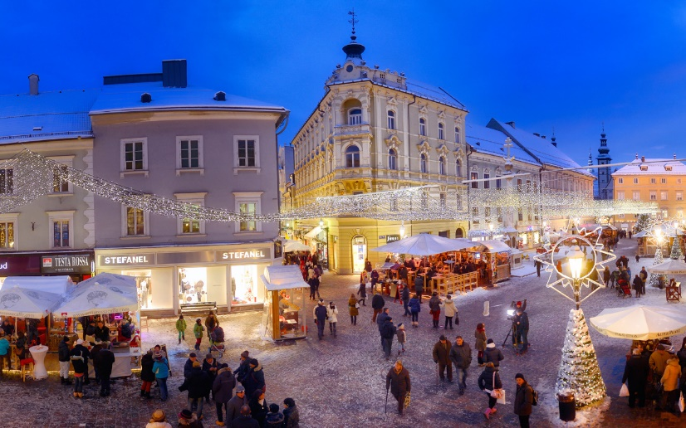
14:30 Christmas market in Klagenfurt
17:00 Trip to Obervellach
18:30 Check – in holiday apartments

„Oberstbergmeisteramt“ (Obervellach) for 2 nights
https://www.oberstbergmeisteramt.com

19:30 Dinner.
Short presentation about hotel activities.
Presentation about LAG Großglockner/Mölltal – Oberdrautal.
Presentation of the study visit program and the next day's program
Tuesday, 03.12.2019

08:00 Breakfast
09:00 Presentation about Multifund and CLLD.
Michael Hohenwarter, LAG Region East Tyrol.
10:00 LEADER forum Austria.
Stefan Niedermoser, LAG Cooperation Austria
11:00 Visit LEADER projects in Obervellach
Obervellach Mainplace.
Presentation of Obervellach's cultural historical route
13:00 Lunch
14:30 Visit LEADER projects in Obervellach
Swimmingpool
Obervellach Small business Park (LEADER Business development project
Groppensteinschlucht (LEADER Tourism development project)

Landgut Moserhof (ELER project)
https://www.landgut-moserhof.at/

Old grade school development for flats LEADER Lurnfeld
19:30 Dinner
Discussion about visited objects.
Presentation of the next day's program

Wednesday, 04.12.2019
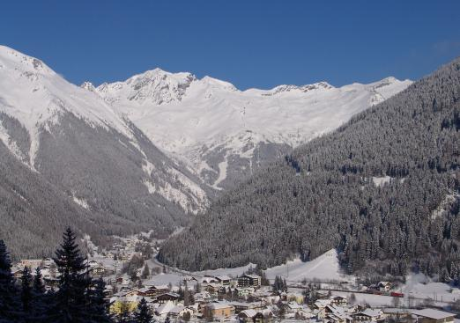
08:00 Breakfast
09:00 Trip to Mallnitz
09:30 Presentation of Mallnitz Railway Station (LEADER and RDP infrastructure improvement project)
10:00 Visit of Mallnitz (LEADER infrastructure improvement and public activity project)
10:30 Visit of the Cultural project promusica Mallnitz (LEADER cultural activity)
12:00 Lunch
13:00 Trip to Flattach
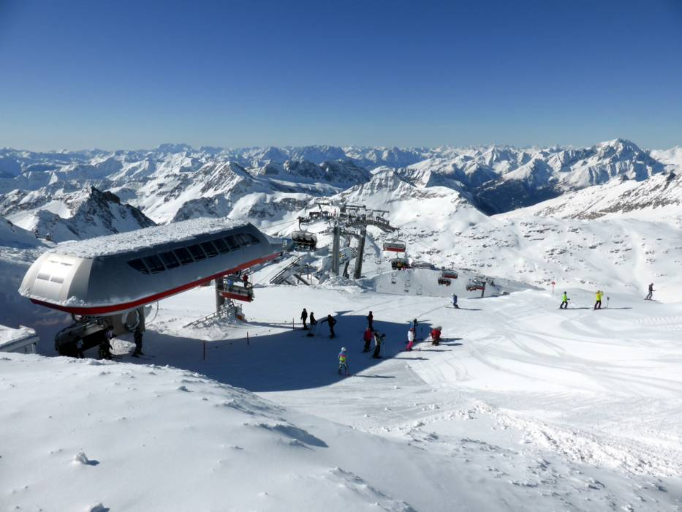
14:30 Visit of the Mölltaler Gletscher Ski Resort. „Experience 3000“. (RDP and LEADER tourism development projects)
16:30 Visit of Sporthotel Mölltal (RDP tourism development project)
17:30 Visit of Youth hostel Mölltaler Gletscher (RDP tourism development project)
18:00 Trip to Heiligenblut. Information about the next day.
19:00 Check – in hotel „Kärntnerhof“. (Heiligenblut) for 2 nights
https://www.hotel-kaerntnerhof.com

20:00 Dinner.
Short presentation about hotel activities. Discussion about visited objects.

Thursday, 05.12.2019
08:00 Breakfast
09:00 Walking in Heiligenblut
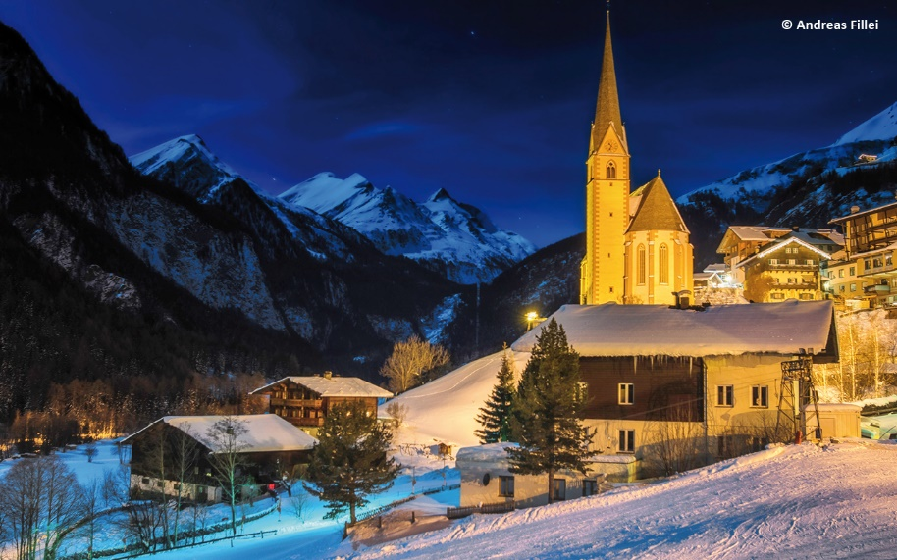
10:00 Lift to Heiligenblut ski resort at the highest Austrian peak Großglockner (RDP tourism development project)
Presentation of the region's Großglockner/Mölltal - Oberdrautal tourism situation
12:00 Lunch
14:00 Arrival to valley

15:00 Visit LEADER and public infrastructure projects in Grosskircheim
Visit of the Großkircheim Kohlbarren (LEADER cultural project)
19:00 Dinner.

Friday, 06.12.2019
06:00 Breakfast
06:45 Departure to the airport
11:05 — 12:25 Ljubljana (LJU) - Frankfurt am Main (FRA), 1:20 hours, Lufthansa
13:30 — 16:55 Frankfurt am Main (FRA) - Tallinn (TLL), 2:25 hours, Lufthansa

Organizer of the visit – LAG Großglockner/Mölltal - Oberdrautal
Gunther Marwieser
+43 664 3252645
region@grossglockner.or.at

